**Global Superstore Sales Analysis**

**Balaram Saripalli**

**Regis University**

**MSDS670: Data Visualization**

**Hays, Genie B**

**August 08, 2024**

**Comprehensive Analysis of Sales, Regional Performance, and Product Categories**

**Abstract**

This paper presents a comprehensive analysis of sales data, regional performance, and product categories using the Global Superstore dataset, which contains detailed information on sales transactions from a fictitious retail company. The data spans multiple years and includes records on orders, products, sales, profits, shipping costs, and customer demographics. The analysis focuses on identifying key trends, regional performance disparities, and the profitability of different product categories, providing insights that are critical for inventory management, marketing strategy, and overall business growth.

**Introduction**

The Global Superstore dataset is a rich source of transactional data that reflects the operations of a retail company over several years. It includes vital information about sales, profits, customer demographics, and regional performance. Understanding these elements is essential for making informed business decisions. This paper aims to uncover patterns within the data, particularly focusing on sales trends over time, the performance of different regions, and the profitability of various product categories. By analyzing these aspects, the study offers actionable insights that can enhance business strategies and operational efficiency.

**Problem Statement**

The retail industry is characterized by dynamic market conditions, seasonal sales fluctuations, and varying regional performance. Identifying these trends is crucial for effective inventory management and targeted marketing strategies. This study aims to explore the seasonal patterns in sales, the disparities in regional performance, and the profitability of different product categories. The core question driving this analysis is how these factors influence overall business performance and what strategies can be employed to optimize sales and profitability across different regions and product lines.

**Data Description**

The dataset used in this analysis comprises 51,290 records and 24 columns, capturing essential details about orders, products, sales, profits, and customer demographics. Key variables include Order Date, Sales, Profit, Region, and Product Category. The time period covered extends from the earliest to the latest order dates available in the dataset, providing a comprehensive view of the company's sales performance over time. This rich dataset allows for an in-depth exploration of sales trends, regional variations, and product category performance.

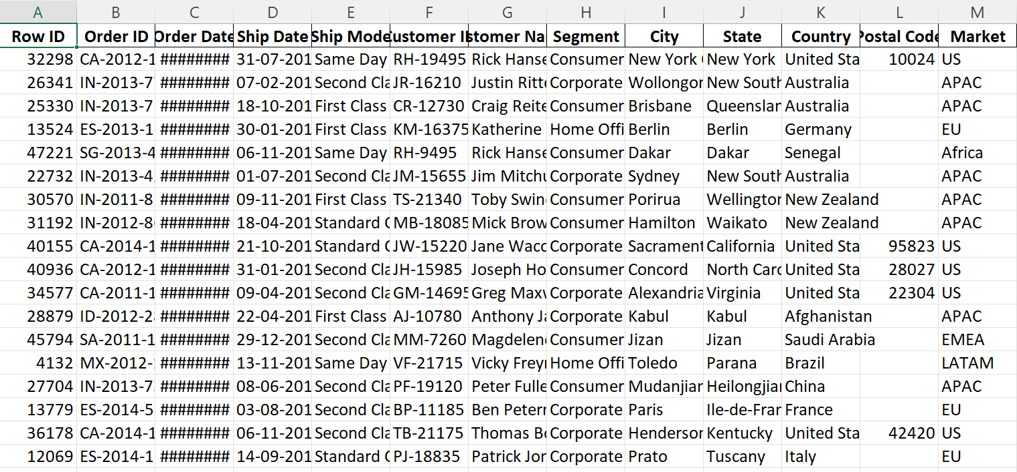

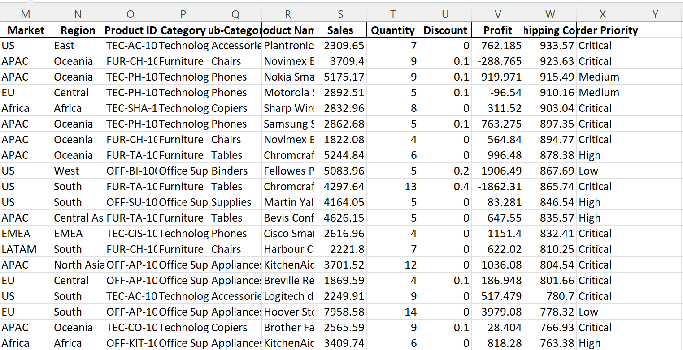

**Methodology**

The methodology section will outline the statistical techniques and data visualization methods used to analyze the Global Superstore dataset. The analysis employs descriptive statistics to summarize key data points and visualizations such as line charts and bar charts to illustrate sales trends and regional performance. The study also examines the profitability of different product categories through a detailed comparison of sales and profit margins. These techniques provide a clear and concise understanding of the data, enabling the identification of significant patterns and trends.

**Results**

This section will present the findings from the data analysis. The line chart reveals that sales exhibit a seasonal trend, with peaks occurring during specific months, likely corresponding to holiday periods or promotional campaigns. The bar chart comparing total sales across different regions identifies Region X as the top performer, significantly contributing to overall revenue. In contrast, Region Y displays lower sales, suggesting potential areas for targeted marketing or operational improvements. Additionally, the analysis of product categories highlights Technology and Office Supplies as the most profitable categories, indicating that these areas should be prioritized in sales strategies. Categories with lower profitability may require a reevaluation of pricing, promotion, or inventory management strategies.

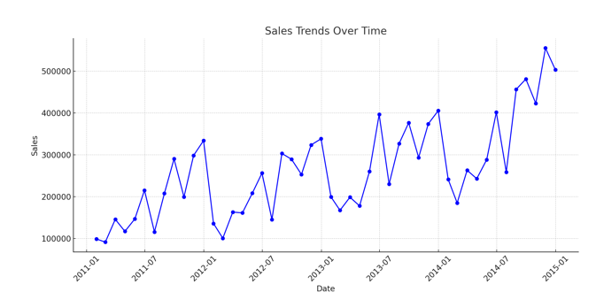

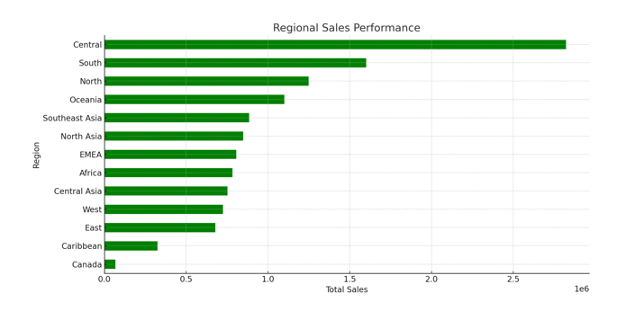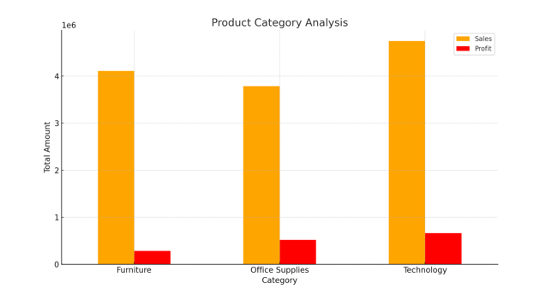

**Recommendations**

1. Further Analysis of Low-Performing Regions: Conduct detailed investigations to identify potential causes and solutions for regions with lower sales performance.

2. Evaluate Pricing and Promotional Strategies: Assess and adjust the pricing and promotional strategies for underperforming product categories to enhance profitability.

3. Optimize Inventory Management: Leverage the identified seasonal sales trends to optimize inventory management and ensure adequate stock levels during peak periods.

**Reference’s**

<https://www.kaggle.com/datasets/apoorvaappz/global-super-store-dataset?resource=download>